|  |  |  |
| --- | --- | --- |
|  | *HELSINKI UNIVERSITY CENTRAL HOSPITAL, HUCH* |  |

|  |  |
| --- | --- |
| Department of Oncology / Physics  Antti Kulmala | 2016/05/27 |

## TrueBeam Radiotherapy Accelerator Beam Data

### Introduction

Research’s purpose is to achieve (i) input data for photon (AAA, AXB, PO, DVO, PGO and PRO) and electron (GGPB) dose calculation algorithms and (ii) reference data for calculation verification. Data collection includes photon beams: 6 MV, FFF-6 MV, 10 MV, FFF-10 MV and 15 MV and electron beams: 6 MeV, 9 MeV, 12 MeV and 16 MeV. Beam data wholeness follows recommendations given for photon and electron algorithms in Eclipse algorithms reference guide.

Studies clinical purpose is to achieve reference input data for TrueBeam accelerators treatment beams.

### Measurements

Photon beam measurements are made using ether an ionization chamber or a diode detector. Ionization chamber is mainly used for data collection in medium and large fields and diode detector is used in radiation measurements in small fields. Please note that in this study absorbed dose to water is observed indirectly through measurement of ionization or diode current. All measured data is relative.

Source-to-Phantom-Distance, SPD 95 cm is used in photon beam data measurements. Electron beam data is measured using SPD 100 cm. Photon data includes measured transmission factors for mlc, tray and block.

Absolute dose calibration for photon and electron beams is given in IAEA calibration geometry.

### Results

Extensive, high quality and clinically usable beam data has been achieved.

Four matched TrueBeam accelerators two placed at Cancer Center Helsinki, one at Kymenlaakso Central Hospital and one at South Karelia Central Hospital are sharing presented beam data. We estimate that radiotherapy treatments for 50 new patients per week are planned using algorithms (e.g. AAA and PO) setup with the delivered data.

Helsinki, the 27th of May 2016

___________________________________ ___________________________________

Antti Kulmala, Physicist   
Helsinki University Central Hospital,   
Department of Oncology

# Environment

### Treatment Unit

This study is carried out with a treatment unit, which has been installed in Kymenlaakso Central Hospital on spring 2012. The treatment unit has five photon energies, four electron energies, multi-leaf-collimator (Millenium 120), 3-degree couch (Exact IGRTcouch thin 6 cm) and kV on board imager (OBI). Primary collimators limit maximum field size to 40 x 40 cm2 at isosenter plane. Studied photon beams are collimated with movable jaws, and investigated electron beams are collimated with tubus accessories equipped with factory made block frames.

Information of beam characteristic can be found in Table 1a, 1b and 1c. In pre-measurement evaluation treatment unit is found to be in good condition. All measurements have been done in accelerators service mode.

**Table 1a: Studied treatment unit.**

|  |  |
| --- | --- |
| **Attribute** | **Value** |
| Machine Model | TrueBeam (sn:1219) |
| Machine Scale | Varian IEC |

**Table 2b: Studied photon beams.**

|  |  |  |  |  |  |  |
| --- | --- | --- | --- | --- | --- | --- |
| **Attribute** | **Unit** | **Value** |  |  |  |  |
| Acceleration Potential NACP | [MV] | 5.3 (6) | 10.2 (10) | 13.3 (15) | 4.1 (6-FFF) | 7.2 (10-FFF) |
| Depth of dose max of  FS: 10.0 x 10.0 cm2 | [cm] | 1.4 | 2.3 | 2.7 | 1.4 | 2.0 |
| J100 / J200 |  | 1.745 | 1.587 | 1.539 | 1.835 | 1.657 |

**Table 3c: Studied electron beams.**

|  |  |  |  |  |  |
| --- | --- | --- | --- | --- | --- |
| **Attribute** | **Unit** | **Value** |  |  |  |
| Probable Energy TRS-277 | [MeV] | 6.2 (6) | 9.0 (9) | 12.4 (12) | 16.3 (16) |
| Depth of dose max of  TUBUS: 20.0 x 20.0 cm2 | [cm] | 1.3 | 2.1 | 2.7 | 3.1 |
| R50ion | [cm] | 2.33 | 3.55 | 4.94 | 6.65 |

# Measurements

### Measurement Equipment

Measurements have been made in ~ 40 x 40 x 40 cm3 Blue Phantom 2® -water phantom system. In this phantom detectors are attached to robotic arm, which is computer driven. With electronic online detectors used in this study absorbed dose is measured indirectly thought measurement of charge. Details of measurement equipment are shown in Tables 2a and 2b. Prior to beam data measurements the water phantom system has been benchmarked. In these test phantom has been proven to be as good as new.

**Table 4a. Beam data measurement equipment - overview.**

|  |  |
| --- | --- |
| Water Phantom System | IBA Dosimetry GmbH  - Blue Phantom 2 - water phantom  - CCU - electrometer  - OmniPro Accept 7.1a - software |
| Ionization Chamber(s) | IBA Dosimetry GmbH  - IC13 (sn:9917) (Field, Photons)  - IC13 (sn:9918) (Reference)  PTW-Freiburg GmbH  - ROOS (sn:0983) (Field, Electrons) |
| Diode(s) | Sun Nuclear  - 1110000-3 (sn:1110038) (Field)  - 1111000-3 (sn:1110066) (Reference) |

**Table 2b. Measurement equipment – detector details.**

|  |  |  |  |
| --- | --- | --- | --- |
| **Attribute** | **Value** | **Value** | **Value** |
| Instrument | IC13, IBA (IC) | SunNuclear (Diode) | ROOS, PTW (IC) |
| Detector Type | Ionization chamber | Diode detector | Ionization chamber |
| Nominal Volume | 0.13 cm3 | 0.2 μm3 | 0.35 cm3 |
| Sensitive Volume | Ø 0.6 cm — 0.6 cm | Ø 0.2 cm — 0.03 cm | Ø 1.5 cm — 0.2 cm |
| Sensitivity | 3.5 nC/Gy | 47.5 nC/Gy | 11.0 nC/Gy |
| Charge Collection Potential | 300 V | 0 V | 200 V |

### Measurement Setups

Machine geometry: Gantry 0o and Collimator 0o has been used (see figure 1). Phantom alignment, gantry’s tilt angles and detector localization (position of field center) have been ensured with profile measurements before beam data collection.

Ionization chamber, IC13 has been positioned horizontally to Blue Phantoms robotic arm in all measurement situations. On the other hand diode detector has been setup vertically (instruments tail pointing to positive depth direction) as well as Roos chamber (instruments rotation axis parallel to beam axis). Depth directional placement of IC13 chambers has been made using water surface in other words we positioned ionization chamber’s rotation axis to water surface to normalize detectors depth directional setup. In measurement situations we used -1.5 mm shift to correct position deviation between effective measurement point and chambers axis. Roos chamber’s depth directional setup has also been made using water surface. Chambers front surface was set to water level. In measurement situations we used 1.0 mm shift to correct position deviation between effective measurement point and chambers front surface. Diode detectors depth directional setup has been made cross-referring to depth dose profile measured with IC13 or ROOS chamber.

Profile measurements have been made using reference detector whenever possible. Reference detector has been positioned in air. Use of the reference detector enables use of “continuous” –measurement mode, in which field chamber moves continuously trough the measurement profile. When reference detector has been used presented measurement result is ratio between field instruments readout and reference detectors readout.

### Predefined Absolute Dose Calibration

We have chosen following absolute dose calibration for studied treatment beams. To water medium dose of one Gray (1.000 Gy) shall be created with hundred monitor units (100 MU) in next geometry and machine configuration:

(1) Source to Phantom Distance 100.0 cm.

(2) Effective Point of Measurement at PDDmax depth.

For photons:

(3P) Field Size 10.0 x 10.0 cm2.

For electrons:

(3E) Tubus Size 20.0 x 20.0 cm2.

All beams have been calibrated prior to beam data collection.

# Results

# Results

Measurement results delivered with this document are presented primary in w2CAD format. When this format is not served, data is delivered in ASCII format. We have also enclosed raw measurement data to this work. The purpose is to leave raw data in storage for potential future use.

Presented profile data has been edited, to be precise, filtered and smoothed. Interpolations have been used to get evenly distributed data points and smoothing has been used to get noise out of data. OAR-profiles have been centered, made symmetric using mean value of both profile sides and normalized using origin position. For more detailed information please see “EDITLOKI*” –documents.

Photon PDDs for field sizes: 3 x 3 cm2, 4 x 4 cm2 and 5 x 5 cm2 and CRs for field size 5 x 5 cm2, have been measured with diode detector. Output factors for fields, where smaller field side is 3 cm or less, are also measured with diode detector. All other photon beam data is measured using ionization chamber. Data of electron beams is primary measured with ionization chamber. Diode results are collected to verify ionization chamber results.

**Uncertainties**

In theory to convert relative ionization to relative dose we have to correct for dependencies on (i) ion-collection and (ii) radiation quality as function of measurement location. In previous reports we have considered these correction and possible uncertainties arising if these corrections are bypassed. Referring to report [A] we can give following summary. At broad beam measurement uncertainty arises from instability of accelerator and measurement devises and uncertainty of ion collection and beam quality. We estimate that in this work combination of uncertainty is ≤ 0.5 % (1σ) for all studied photon beams. If this uncertainty level is see acceptable, delivered ionization data can be used in the raw format as relative dose data.

Uncertainties in radiation measurement conducted with diode arise also from (i) dose rate and (ii) beam quality –dependencies. These dependencies are known from literature. We haven’t made quantitative analysis of them for this study or for used diode. We can note that the used instrument has been benchmarked against ionization chamber in field size range used in this study. Our findings are positive, and the detector has worked foreseeable. We want to give qualitative comment, that used diode detector might see penumbras too steep. Data users are advised to find quantitative uncertainty analysis for diode dosimetry before accepting measured profiles.

Additionally we want to note that detectors macroscopic size (alias volume averaging effect) softens gradients like field penumbra or depth dose maximum. See table 2b to estimate averaging volumes.

Setup uncertainty is estimated to be ± 0.5 mm (for water phantom and detector separately).

# Previous Reports

For more information please review following reports. Measurement details of this study correspond to work presented in document:

(A) Elekta AXESS (Beam Modulator) Beam Data.

For readers how understand finish, we present clinical summary document:

(B) VarianTrueBeam_Kotka2012.

# Comments

(1) For this study we have used approx. 120 work hours and 30 – 40 hours beam on time.

# Figures

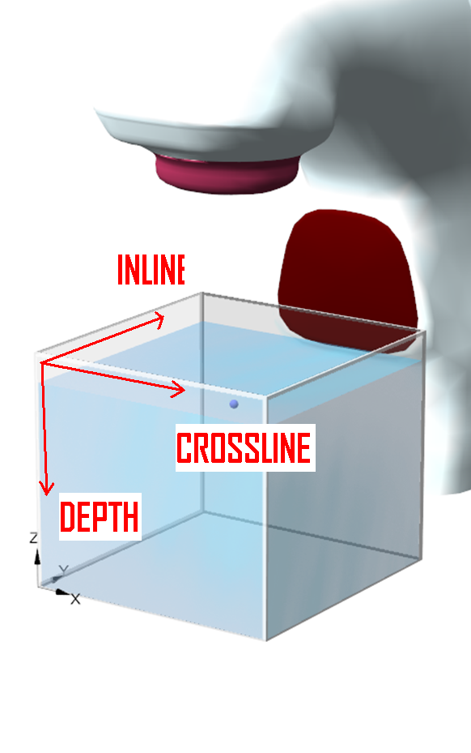

Figure 1. Measurement coordinates (IN, CR, DPTH [IEC61217]) as used in this study. For all measurement situation gantry and collimator angle has been set to 0 degree. [Screen Print: OmniPro Accept 7.1a]